Lab Exercise 2- Working with Git Reset
Lab Exercise: Git Reset
This lab exercise will guide you through the usage of the git reset command in various scenarios. The git reset command is used to undo changes in the Git history, working directory, or staging area. There are three main modes: soft, mixed, and hard.

Objective
- Learn how to use git reset to modify the commit history, unstage files, or discard changes.
- Understand the differences between --soft, --mixed, and --hard reset modes.

Prerequisites
- Install Git on your system.
- Set up a Git repository:
git init git-reset-lab
cd git-reset-lab

Steps
1. Set Up the Repository
- Create and commit an initial file:
echo "Line 1" > file.txt
git add file.txt
git commit -m "Initial commit: Add Line 1"
- Add a second change:
echo "Line 2" >> file.txt
git commit -am "Add Line 2"
- Add a third change:
echo "Line 3" >> file.txt
git commit -am "Add Line 3"
- Check the commit history:
git log --oneline
Example output:
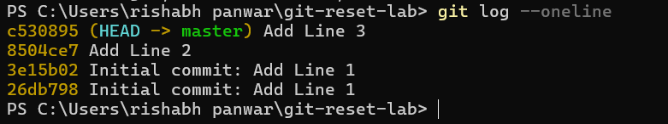
2. Use git reset --soft
This mode moves the HEAD pointer to an earlier commit but keeps the changes in the staging area.
- Reset to the second commit:
git reset --soft HEAD~1
- Check the commit history:
git log --oneline
Output:
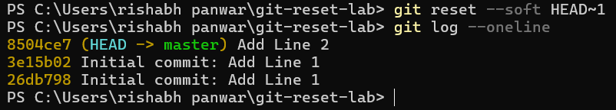
- Verify the staged changes:
git status

Output:
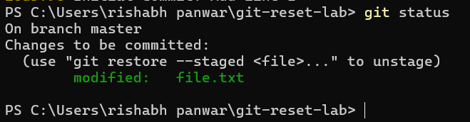

3. Use git reset --mixed
This mode moves the HEAD pointer and unstages the changes but keeps them in the working directory.
- Reset to the first commit:
git reset --mixed HEAD~1
- Check the commit history:
git log --oneline
Output:

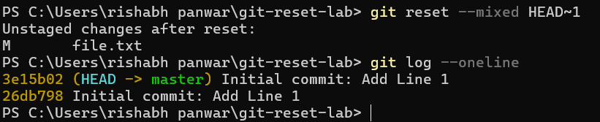

4. Use git reset --hard
This mode moves the HEAD pointer and discards all changes in the staging area and working directory.
- Reset to the initial commit:
git reset --hard HEAD~1
- Check the commit history:
git log --oneline
Output:
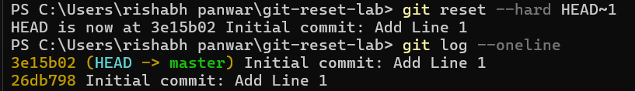
- Verify the working directory:
cat file.txt
Output:
5. Use git reset with a Commit Hash
- Add some changes for demonstration:
echo "Line 2" >> file.txt
git commit -am "Add Line 2"
echo "Line 3" >> file.txt
git commit -am "Add Line 3"
- Get the commit hash for the initial commit:
git log --oneline
- Reset to the initial commit using the hash:
git reset --hard <commit-hash>
- Verify the working directory and commit history:
git log --oneline
cat file.txt
